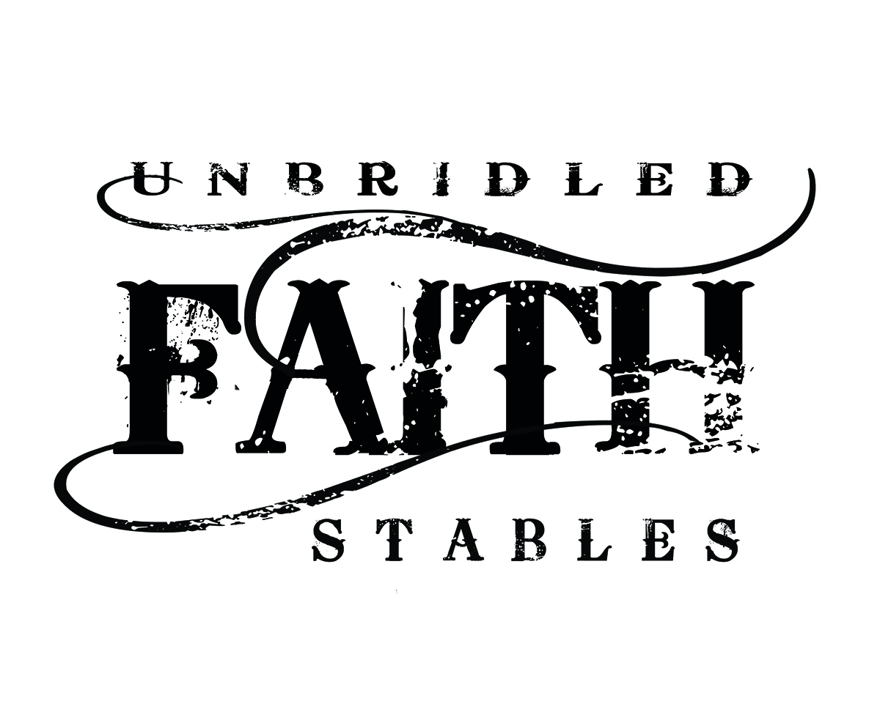
131 Lynn Drive, Cataula, GA 31804 (706)905-7859 or (865)209-5616
unbridledfaithstables@gmail.com
Website: unbridledfaithstables.com

HORSE BOARDING AGREEMENT
WITNESS THIS AGREEMENT this _____ day of _____________, in the year _________, by and between
Matthew and Julie Ward, hereinafter referred to as "Stable," located at 131 Lynn Drive, Cataula, GA 31804, and
___________________________________________ hereinafter referred to as "Boarder."
1. FEES, TERM, AND LOCATION. Boarder acknowledges and accepts those terms set forth in the rate schedule applicable on the date above as issued by Stable, whether said rates be daily, weekly, or monthly. Payment shall be issued in accordance with that rate schedule on a timely basis. Any charges not paid in a timely manner shall be subject to finance charges set forth in the rate schedule. In the event the subject animal is removed from the premises for any reason and returned, this agreement shall be deemed reinstated at rates applicable at the time of said return. Stable reserves the right to notify Boarder within fifteen (15) days of the horse's arrival if the horse, in Stable's opinion, is deemed to be dangerous or undesirable for Stable's establishment. In such case, Boarder shall be solely responsible for removing the horse within seven (7) days of said notice and for all fees incurred during the horse's presence upon the premises. This Contract shall be deemed terminated and concluded upon the payment of all fees.
The boarding fee is due upon the first of the preceding month. In the event said payment is overdue by the 5th of any given month, there will result an initial $30.00 late payment charge starting on the 6th of that month. For each day thereafter, there will be a $10 per day late fee in addition to the initial late fee. After ten (10) days, Stable shall be entitled to exert a lien against said horse, and the property upon the premises as more further described below, for any amounts due, and shall be entitled to enforce said lien and foreclose its interest against said horse and/or equipment for the amount due in accordance with the laws of the State of Georgia.

The initial monthly charge applicable to the services as set forth below shall be ___________ per month/per horse. The type of board I have chosen is:
a) Pasture Board--$150/month
Description: Pasture board is available on a very limited basis for those boarders who have horses that only need pasture and hay. Pasture board does NOT include an available stall or any feedings other than seasonal hay as needed. Run-in will be available in pasture.

b) Partial Board--$350/month
Description: Partial board is for those boarders who want turnout for their horses throughout the day. These horses eat twice daily and enjoy sunshine and exercise in their pasture. They are stalled for inclement weather in their designated stall. Twice daily feedings, hay, shavings for stall s well as other amenenities on the property—two arenas, trails, jumps, wash racks, secure tack room with bathroom and refrigerator. Supplements provided by boarder given with feed per your request. Blanketing available in winter. Daily stall cleaning.

c) Full Board--$375/month
Description: Full board includes twice daily feedings, hay, unlimited stall time and shavings. Access to all ameneties on the property included as in partial board above. Stall mats will be provided for these boarders.

2. DESCRIPTION OF HORSE (S) TO BE BOARDED. Boarder agrees to submit a fully completed Boarder Information Sheet (Addendum A) for each horse boarded upon execution of this agreement. The terms and conditions set forth herein shall be applicable to each and every animal boarded by Boarder.
3. FEED, FACILITIES, AND SERVICES. Stable agrees to provide adequate feed and facilities for normal and reasonable care required to maintain the health and well being of the animals. Hay will be fed twice daily at a maximum of 2 flakes each feeding.
The brand of feed that this Boarder has chosen is _________________________________________and will be provided twice daily at a maximum of 8# per day. Increased amounts may also be fed with financial considerations.
Boarder acknowledges Boarder has inspected the facilities and finds same in safe and proper order. The standard services to be provided herein and the charges therefore are as posted in the office of Stable and are subject to change at Stable's discretion.
Supplements, purchased by Boarders, will be fed by Stable according to specified feeding instructions. If boarder has more than 2 supplements, it is boarder’s responsibility to pre-package, and have available, said supplements for barn manager.
Shavings for stalls will be provided according to type of board chosen. Stable will assist Boarder with blanketing as weather demands, per Boarders requests.
Boarders are required to purchase, separate from boarding fee, their share of fly predators for fly control during spring and summer months. This is usually about a $25 fee per horse per year.

4. RISK OF LOSS AND STANDARD OF CARE.
a) DURING THE TIME THAT THE HORSE (S) IS/ARE IN CUSTODY OF STABLE, STABLE SHALL NOT BE LIABLE FOR ANY SICKNESS, DISEASE, ESTRAY, THEFT, DEATH OR INJURY WHICH MAY BE SUFFERED BY THE HORSE (S) OR ANY OTHER CAUSE OF ACTION, WHATSOEVER, ARISING OUT OF OR BEING CONNECTED IN ANY WAY WITH THE BOARDING OF SAID HORSE (S), INCLUDING LOSS BY FIRE, THEFT, RUNNING AWAY, DEATH OR INJURY DURING THE TERM OF THIS AGREEMENT, WHETHER THE HORSE IS ON THE PREMISES OF THE FARM OR NOT, EXCEPT IN THE EVENT OF NEGLIGENCE ON THE PART OF STABLE, ITS AGENTS, AND/OR EMPLOYEES. THIS INCLUDES, BUT IS NOT LIMITED TO, ANY PERSONAL INJURY OR DISABILITY THE HORSE OWNER (Boarder), OR OWNER'S (Boarder’s) GUEST, MAY RECEIVE ON STABLE'S PREMISES.
b) The Boarder fully understands that Stable does not carry any insurance on any horse(s) not owned by it for boarding or for any other purposes, whether public liability, accidental injury, theft or equine mortality insurance, and that all risks connected with boarding or for any other reason for which the horse(s) in the possession of, and on the premises of Stable are to be borne by the Boarder. Stable strongly recommends equine mortality insurance be obtained applicable to the subject horse(s) by Boarder.
5. HOLD HARMLESS. Boarder shall be solely responsible for all acts and behavior of each horse at all times during the term of this agreement, and in no case shall Stable be liable for any of the horse’s acts and behaviors other than for the exercise of gross negligence on the part of the Stable, its agents or employees in the boarding of the horse(s). Boarder agrees to hold harmless Stable, its agents, and employees from and against any and all damages sustained or suffered by reason of the boarding of the horse(s) for any claims or injuries whatsoever arising out of the boarding and keeping the horse(s), and agree to defend Stable from any and all such claims. Boarder agrees to disclose any and all hazardous or dangerous propensities of horse(s) boarded with Stable.
6. EMERGENCY CARE. Stable agrees to attempt to contact Boarder should Stable feel that medical treatment is needed for said horse(s), but, if Stable is unable to contact Boarder, Stable is then authorized to secure emergency veterinary, and blacksmith care required for the health and well-being of said horse(s). All costs of such care incurred shall be billed to Boarder directly if those arrangements can be made with veterinarian. Boarder will be responsible for the payment of all costs incurred as a result of this care and treatment, with the provision that if the treatment provider estimates the total cost to be greater than $_________________, Boarder authorizes Stable to:
__________________________________________________________________________________________________________________________________________________________________________________________________________________________________________
STABLE SHALL ASSUME THAT OWNER DESIRES SURGICAL CARE IF RECOMMENDED BY A VETERINARIAN IN THE EVENT OF COLIC, OR OTHER LIFE-THREATENING ILLNESS, UNLESS STABLE IS INSTRUCTED, HEREIN OR ON OWNER'S INFORMATION SHEETS, BY OWNER THAT THE HORSE (S) IS/ARE NOT SURGICAL CANDIDATES.
Boarder agrees to notify Stable of any and all change of addresses, emergency telephone numbers, itineraries or other information reasonably necessary to contact Boarder in the event of an emergency. In the event Boarder departs for vacation or is otherwise unavailable, prior to departure Boarder shall notify Stable as to what party is authorized to make decisions in the Boarder's place with regard to the health, well-being, and/or medical treatment of the horse(s).
On Addendum B, Boarder shall provide Stable with proof of all insurance in connection with the horse(s).
7. LIMITATION OF ACTIONS. Any action or claim brought by Owner against Stable for breach of this Contract or for loss due to negligence must be brought within ninety (90) days of the date such claim or loss occurs. Unless Boarder files such notice within the prescribed time, Boarder waives any and all rights that Boarder may have against Stable for any liability arising under this Agreement for damages to the horse(s).
8. FARRIERS AND WORMING. Owner agrees to provide the necessary shoeing and worming of the horse(s) as is reasonably necessary, at Boarder's expense. Boarder agrees to provide Stable with all health records with regard to the horse(s). The deworming schedule is provided and it is owner’s responsibility to adhere to this deworming schedule.
Boarder agrees to have the horse(s) vaccinated, at the Owner’s expense, on the following Stable schedule:
a) Rabies – 1 time per year
b) Flu/Rhino – 2 times per year
c) EWT – 2 times per year
d) West Nile – 2 times per year (as recommended by vet)
e) Strangles vaccine – 1 time per year
This schedule is subject to change based on veterinarian recommendations, at which time Owner’s will be notified. If any other vaccinations are needed or required by Georgia law, those as well will be required to be administered at Owner’s expense.
9. OWNERSHIP-COGGINS TEST. Owner warrants that he owns the horse(s) and will provide proof satisfactory to Stable of the negative Coggins test prior to the arrival of the horse(s) to the Stable. The Coggins test will need to be from the immediately preceding six months. The Owner’s vet will also perform a Coggins test 1 time each year. Certification of each vaccination and the result of each test will be given promptly to the Stable.
10. CHANGES OR TERMINATION OF THIS AGREEMENT. It is agreed by the parties that this Agreement may be changed or terminated upon thirty (30) days notice, regardless of the rental period. All notices must be issued in writing unless otherwise agreed upon by the parties. If after 90 days of a terminated contract, by either party, there is horse(s)/property of the Boarder that remains on the property, all will become the property of the Stable. Stable shall sell or give horse(s)/property away at their discretion. The posting of updated rate schedules in a conspicuous or open place in Stable's office shall constitute notice of any and all rate changes or regulation changes as may be deemed appropriate by Stable.
11. RULES AND REGULATIONS. The Owner agrees to abide by all the rules and regulations of the Stable. In the event someone other than the Owner shall call for the horse(s), such person shall have written authority signed by the Owner to obtain said horse(s).
12. DAMAGES. Boarder agrees to reimburse Stable for any damages to premises other than normal wear and tear. Damages due to recognized vices of horses such as cribbing, kicking stalls, or injuring another horse, shall NOT be considered normal wear and tear.
13. NON-ASSIGNMENT. Boarder will not assign this Agreement or his rights under this Agreement unless Stable agrees thereto in writing.
14. OWNERSHIP. Boarder specifically warrants and represents that Boarder owns the horse(s) and that there is not now a lien or other encumbrance against the horse(s).
15. PROPERTY IN STORAGE ON STABLE'S PREMISES. Owner may store certain tack and equipment on the premises of Stable at no additional charge to Owner, provided there is adequate space determined by Stable. However, Stable shall not be responsible for the theft, loss, damage or disappearance of any tack or equipment or other property stored at Stable as same is stored at the Owner's risk. Stable shall not be liable for the theft, loss, damage, or disappearance of any tack or equipment taken to horse shows or clinics.
16. INHERENT RISKS AND ASSUMPTION OF RISK. The undersigned acknowledges there are inherent risks associated with equine activities such as described below and hereby expressly assumes all risks associated with participating in such activities. The inherent risks include, but are not limited to the propensity of equines to behave in ways such as, running, bucking, biting, kicking, shying, stumbling, rearing, falling or stepping on, that may result in an injury, harm or death to persons on or around them; the unpredictability of equine's reaction to such things as sounds, sudden movement and unfamiliar objects, persons or other animals; certain hazards such as surface and subsurface conditions; collisions with other animals; the limited availability of emergency medical care; and the potential of a participant to act in a negligent manner that may contribute to injury to the participant or others, such as failing to maintain control over the animal or not acting within such participant's ability.
17. ENTIRE AGREEMENT. This contract represents the entire agreement between the parties and any prior understanding or representation of any kind preceding the date of this Agreement shall not be binding upon either party. No other agreements, promises, or representations, verbal or implied, are included herein unless specifically stated in this written agreement. This contract is made and entered into in the State of ___GEORGIA _______, and shall be enforced and interpreted in accordance with the laws of said State. This contract shall bind to the benefit of the respective heirs, representatives, successors and assigns of the parties. All references to the Stable herein include its agents and employees.
18. ENFORCEABILITY OF CONTRACT. In the event one or more parts of this contract are found to be unenforceable or illegal, the other portions hereof shall be deemed in full force and effect.
19. RECEIPT OF HORSE (S). Stable hereby acknowledges receipt of the above-described horse(s) in the condition and on the terms set forth in this agreement.
20. DEATH. In the unfortunate incident of a horse’s death, many decisions need to be made. We would prefer to not bury horses on our property. Each case will be addressed as these tragic circumstances arise. After a death, the horse will be tarped and secured until the Owner can arrange for removal/burial. The body must be buried or removed within 24 hours of the death.
21. PASTURE AND HERD MANAGEMENT. Pasture and herd management is entirely at the discretion of the barn manager and barn owners based on what is best for the herd of horses we have and their inherent personalities. As well, stall arrangement may also be changed if necessary.
Warning: Under Georgia law, an equine activity sponsor or equine professional is not liable for any injury to or the death of a participant in equine activities resulting from the inherent risks of equine activities, pursuant to Chapter 12 of Title 4 to the Official Code of Georgia Annotated.

Signature of Owner (or Authorized Agent) __________________________________
Signature of Owner's Parent or Guardian ___________________________________ (if owner is a minor)
Address: _________________________________________
City/State/Zip: _____________________________________
Telephone: ____________ (Day) Telephone: ____________ (Evening)
Owner’s Email: ____________________________________
Stable Owner: ____________________________________
Authorized Agent Signature of Stable Owner: ____________________________________

_______ Initial here to acknowledge that boarder has received and read list of surcharge items. If so applicable, boarder will receive a bill at end of month for those charges incurred. If any charges exist, those charges are due with board at time of next board payment.

